ABAP Debugger

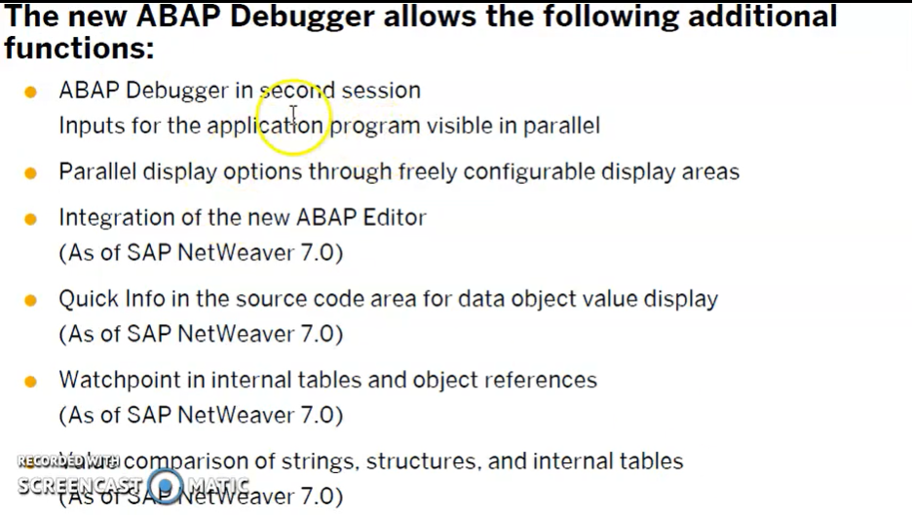

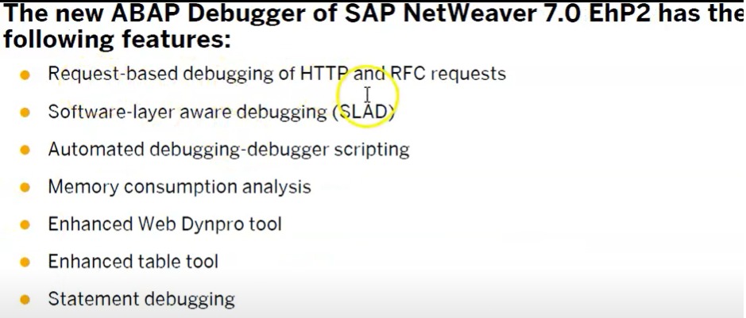

**EXTRACT**

[Quick Reference](javascript:call_link('abapextract_shortref.htm'))

**Obsolete Syntax**

**EXTRACT [ header | field_group ].**

**Effect**

This statement appends the current content of the fields previously included in the field group **header** or **field_group** using the statement [**INSERT**](javascript:call_link('abapinsert_fg.htm')) to the [extract dataset](javascript:call_link('abenextract_dataset_glosry.htm')) of the program. If there is no field group specified after **EXTRACT**, the field group **header** is added implicitly.

**Example**

This example continues the example under [**INSERT**](javascript:call_link('abapinsert_fg.htm')). The fields of the field groups **flight_info** and **flight_date** are filled in a nested **LOOP** and appended to the extract dataset.

**REPORT ...  
  
DATA: spfli_wa TYPE spfli,  
      sflight_wa  TYPE sflight,  
      spfli_tab   LIKE TABLE OF spfli_wa,  
      sflight_tab LIKE TABLE OF sflight_wa.  
  
FIELD-GROUPS: header, flight_info, flight_date.  
  
START-OF-SELECTION.  
  INSERT: spfli_wa-carrid spfli_wa-connid sflight_wa-fldate  
            INTO header,  
          spfli_wa-cityfrom spfli_wa-cityto  
            INTO flight_info.  
  
  SELECT *  
         FROM spfli  
         INTO TABLE @spfli_tab.  
  
  SELECT *  
         FROM sflight  
         INTO TABLE @sflight_tab.  
  
  LOOP AT spfli_tab INTO spfli_wa.  
    sflight_wa-fldate ='--------'.  
    EXTRACT flight_info.  
    LOOP AT sflight_tab INTO sflight_wa  
            WHERE carrid = spfli_wa-carrid AND  
                  connid = spfli_wa-connid.  
      EXTRACT flight_date.  
    ENDLOOP.  
  ENDLOOP.**

GET  
Syntax : GET <nodename>.  
GET event occurs(triggers) when the logical database has read a line from the node <nodename> and makes it available to the work area in the program declared using the statement NODES <nodename>.

GET LATE  
Syntax : GET <nodename> LATE  
GET LATE event is triggered when all of the data records for a node and all the data records of the sub-nodes under it in the hierarchy of the logical database have been read.